# **CprE 381, Computer Organization and Assembly-Level Programming, Spring 2017**

# **Lab 1 Report**

Lab Partners ____Ningyuan Zhang________________

______________________________________________

______________________________________________

## Section /Lab Time ___A Tue 8:00____

***Refer to the highlighted language in the lab 1 instruction for the context of the following questions****.*

1. [Part 1 (b)] Reference the circuit diagram at the end of this document (some parts simplified). There are 30 labeled areas in the diagram. For each of these labels, specify where (VHDL file and line number) these values are located – some will be found in more than one place. Also attempt to explain the functionality of each label as it occurs in the code. (3 points)

Below are their locations:

1. Quadratic line 50, 69
2. Quadratic line 25, 70, 76, 84
3. Quadratic line 51, 75
4. Quadratic line 52, 91
5. Quadratic line 24, 36, 43, 68, 74, 83, 89,98
6. Quadratic line 69, Multiplier line 29, 38, 41
7. Quadratic line 70, Multiplier line 30, 38, 41
8. Multiplier line 41
9. Multiplier line 40
10. Quadratic line 71, Multiplier line 31, 41
11. Quadratic line 67
12. Quadratic line 75, Multiplier line 29, 38, 41
13. Quadratic line 76, Multiplier line 30, 38, 41
14. Quadratic line 77, Multiplier line 31, 41
15. Quadratic line 73
16. Quadratic line 90, Adder line 29, 38, 41
17. Quadratic line 91, Adder line 30, 38, 41
18. Quadratic line 92, Adder line 31, 41
19. Adder line 40
20. Adder line 31, 41
21. Quadratic line 88 (g_Add1) Quadratic line 84, Multiplier line 29, 38, 41 (g_Mult3 iA)
22. Quadratic line 85, Multiplier line 30, 38, 41
23. Quadratic line 86, Multiplier line 31, 41
24. Quadratic line 82
25. Quadratic line 99, Adder line 29, 38, 41
26. Quadratic line 100, Adder line 30, 38, 41
27. Quadratic line 101, Adder line 31, 41
28. Quadratic line 97
29. Quadratic 27, 101
30. Quadratic 22, 29, 31
31. [Part 1 (h)] In your report, provide a brief explanation of how the timing waveform corresponds to your understanding of the adder design. (2 points)

Below are screen shots from the Lab 1:

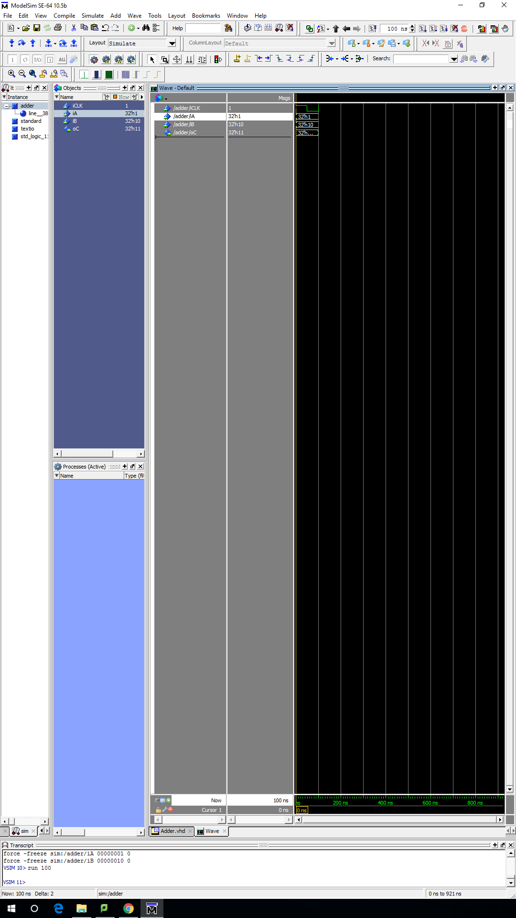

this graph shows the program Quadratic and its result after running, the clock kicked once to get the result.

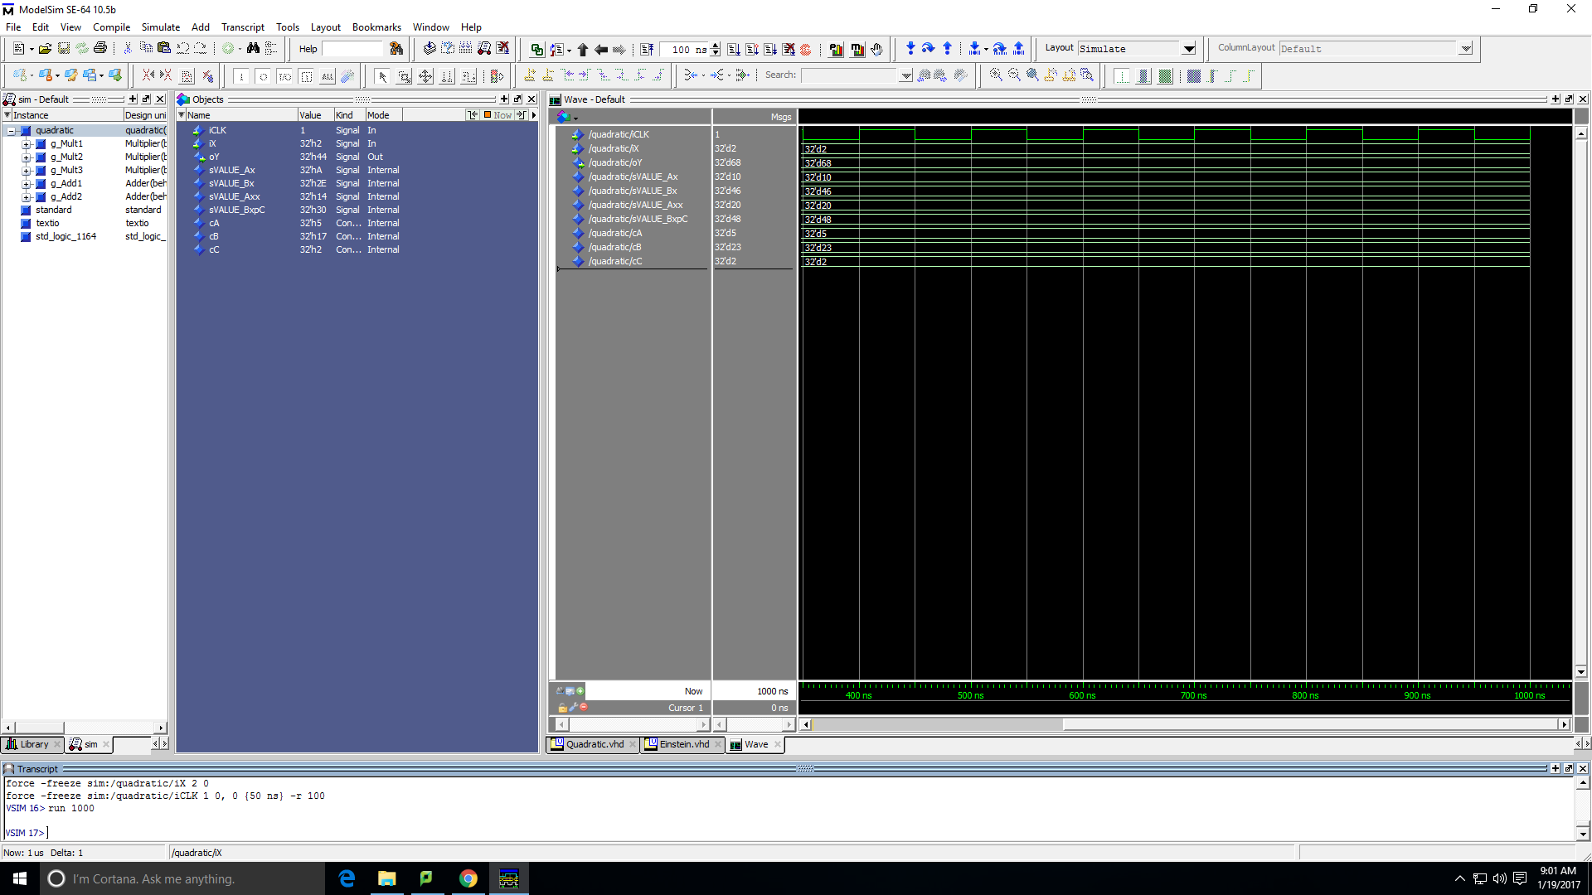

this diagram shows the program Einstein, and it ran 1000 ns but got the result in the first ns.